SIR VITHALDAS THACKERSEY COLLEGE OF HOME SCIENCE
(AUTONOMOUS)
S.N.D.T. WOMEN'S UNIVERSITY
Mumbai

SVT/Exams/2021-22/74 Important Notice 2nd February 2022

F. Y. B.Sc. Semester I Examination Results (2021-22)

F.Y. B.Sc. Home Science Students who appeared for the First Semester Examination (2021-22) can check their results online on 3rd February 2022 3.00 PM onwards. The students are requested to follow the steps appended below to check their First Semester Results.
1. Visit college website (http://svt.edu.in/) Scroll down to “Student Notices” Section.
2. Click on the link mentioned in the “Student Notices” section. (http://svt.edu.in/results/)
3. Students should be able to see below appended screen when the link is opened. Enter your 4-digit college registration number in MIS User ID field & click on Get Results.
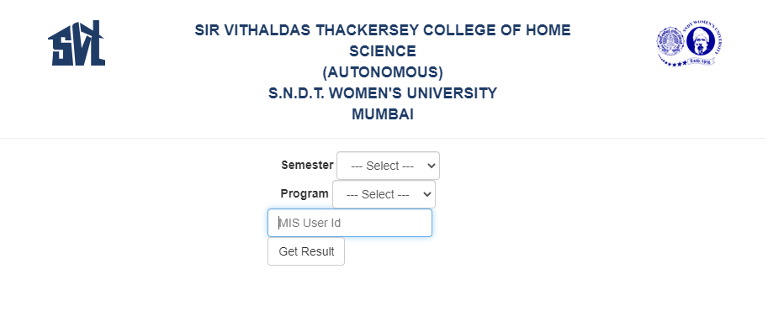
Important Instructions:
- Make sure you enter correct college registration number in MIS user ID field.
- Do not enter spaces in between your MIS user ID number.
- The results are available for First Semester REGULAR students only.

Please contact COE, Examination Department in case of any queries at email - coe@svt.edu.in

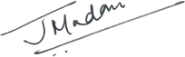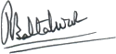
Principal Controller of Examinations

